**Instructions - Employee Listing for Lay Health Insurance Employer Charges**

The [Parish and School Budget Guidelines](http://www.archindy.org/finance/parish/guidelines.html) contain the Employer Health Insurance Rates for fiscal year 2023-24.

**Employer rate is the same regardless if employee coverage is single or family.

Billing to parishes, schools, and agencies for medical and dental insurance is based on Paylocity deductions. A listing of employees included in the monthly charge for Lay Health Insurance Premiums can be obtained by running the “Deduction Listing” report in Paylocity. Note that you will need to multiply the number of employees in the Deduction Listing report by the Employer Health Insurance Rates per the table above to recalculate your location’s overall charge.

Below are instructions for running the “Deduction Listing” report in Paylocity.

* From the Reports & Analytics menu > Select Reporting Dashboard
* In the Reports section under Name search for: **deduction%** which will pull up any standard report with the name “deduction”
* The Deduction Listing report will appear > click on the report name to open the Deduction Listing report parameters so you may adjust the report settings before running the report.

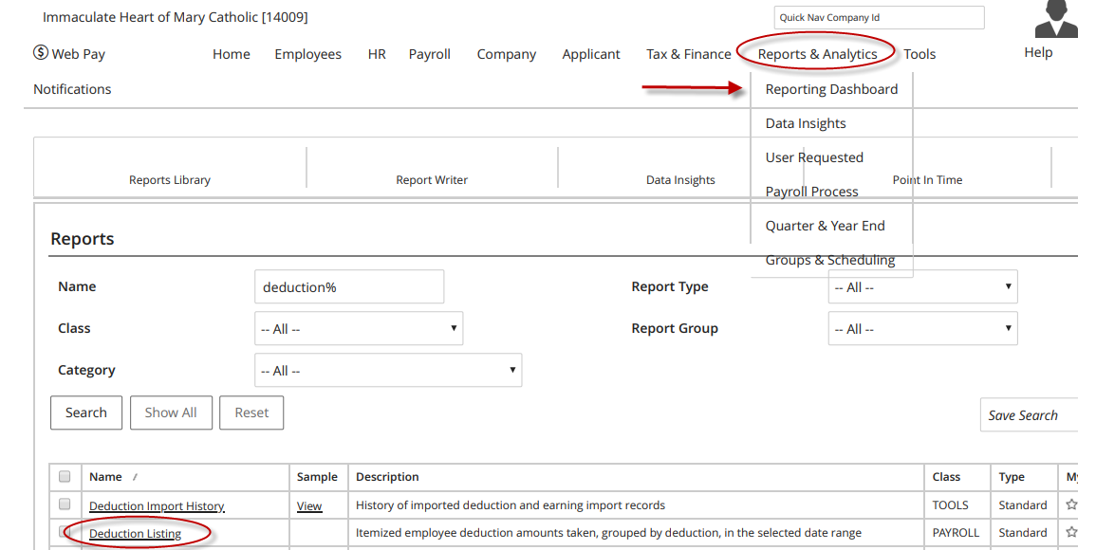

**Payroll Filters**

* Select the ‘Process Date From Process Date To’ radio button so you may select the payroll processing dates for the month
* Process From = first pay date in coverage month
* Process To = last pay date in coverage month

For example: the October statement billed September coverage. The Process From check date will be September 8th and the Process To check date will be September 22nd.

**Standard Filters**

* The default settings in this section can remain as they appear in default

**Optional: Cost Centers & Report Options**

If you require a breakout of the lay health charges by cost center, you can use the options in the Cost Centers section to accomplish this. Not all locations are utilizing cost centers the exact same way, so you may have to use different options depending upon how your location’s cost centers are set up.

**Additional Filters**

* Deduction = select the following 4 deductions
  + DENT – employees with the dental employee deduction will appear
  + HLTH – employees with the health employee deduction will appear
  + DTLS2 – religious employees with the dental deduction will appear
  + HLTS2 – religious employees with the dental deduction will appear

**Running Report**

* After you have completed selections on the report click on the red Export button, found at the top right portion of the screen.
* A pop-up will appear allowing you to select the export type (PDF, excel), you can name the export if helpful, choose how to sort the export, and other display options.
* Once export options are complete, click on the red Run button.

**Report Retrieval**

* Go to Reports & Analytics > Reporting to retrieve the Deduction Listing report you just ran.
* Select Report Pickup.

* Scroll down to the bottom of the Deductions Listing report to view the employee count by deduction code. The bottom of the report will appear with the Employee Count and Description for Dental and/or Health Insurance.

**Note:** The deduction listing report lists the employee name, deduction code and corresponding employee deduction amount. The Amount column appearing totals the employee deductions, not the employer deductions. The only information you need from here is the employee count by deduction code.

* Multiply the following deduction code employee count by the following Employer Health Insurance Monthly Rates:
  + DENT & DTLS2 = Employee Count X $41.92 per employee
  + HLTH & HLTS2 = Employee Count X $872.08 per employee

An example of how the Deduction Listing report totals appears here:

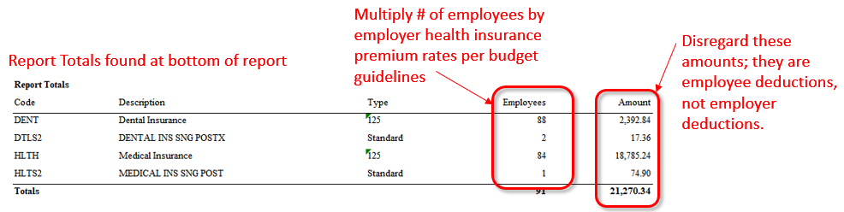

In this example, the employee count for dental coverage of 90 (88+2) needs to be multiplied by the $41.92 Employer Dental Insurance Premium Rate per the Budget Guidelines (rates also shown at the top of this file). The employee count for health coverage of 85 (84+1) needs to be multiplied by the $872.08 Employer Health Insurance Premium Rate. The sum of the Dental and Health calculated charges should be equal to the Lay Health charges on the monthly Billing Statement. A standard template for this calculation has been provided as a separate attachment, and a screen shot is shown below of the calculation.

If you have any questions at all, please contact [Jenny Zelik](mailto:jzelik@archindy.org) for assistance (or, in Jenny’s absence, [accountingservices@archindy.org](mailto:accountingservices@archindy.org) or 317-236-1410).